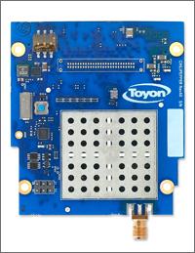

Chilipepper Getting Started Guide

[embedded@toyon.com](mailto:embedded@toyon.com)

[embedded@toyon.com](mailto:embedded@toyon.com)

Toyon Research Corp.

embedded@toyon.com

[embedded@toyon.com](mailto:embedded@toyon.com)

# Introduction

Chilipepper is a FMC card meant to assist in the rapid development and prototyping of radio waveforms. This getting started guide showcases the radio board by providing a serial port bridge between two computers using a pair of radios that are composed of ZED and Chilipepper boards.

# Hardware Setup

Perform these steps for hardware setup.

* Attach Chilipepper boards to FMC sockets and attached antenna
* Check to make sure dip switch 1 on Chilipepper and the others are low
* Make sure all dip switches on the ZED board are low (towards the edge of the board)
* Make sure Vadj on ZED is set for 2.5V
* Make sure board mode selection MI04 and MI05 are jumpered high and all others are low
* Load supplied BOOT.BIN file to the SD card and insert it into the ZED board
* Attach USB cables to the UART and computer , making sure the device driver for the USB to UART loads correctly

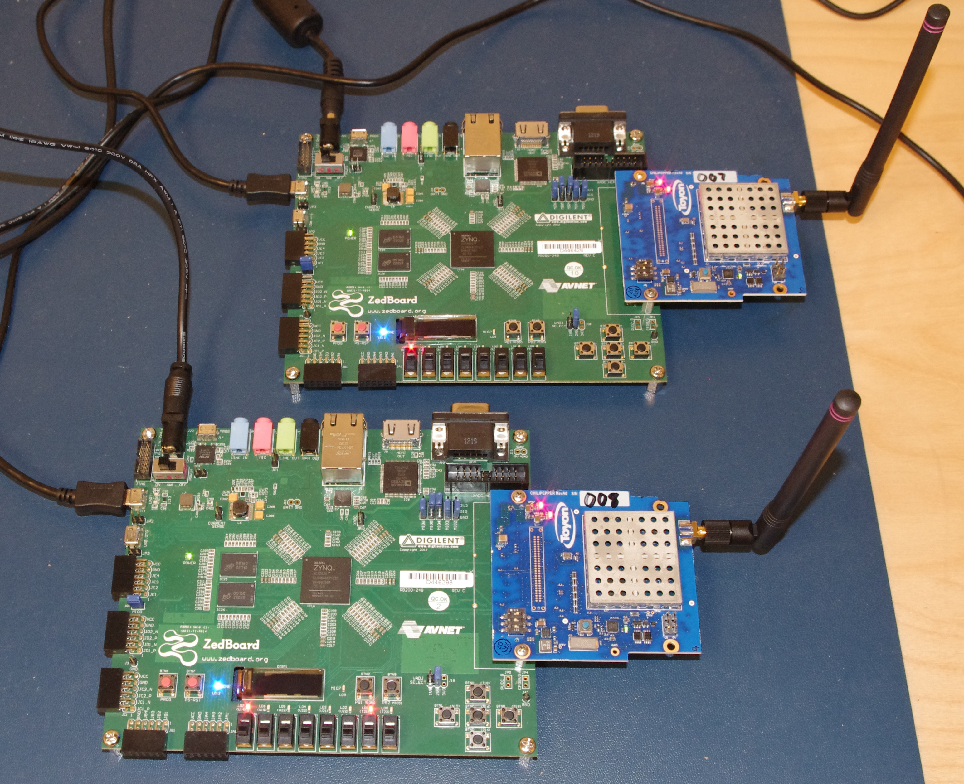

Figure - Pair of radios on the desktop.

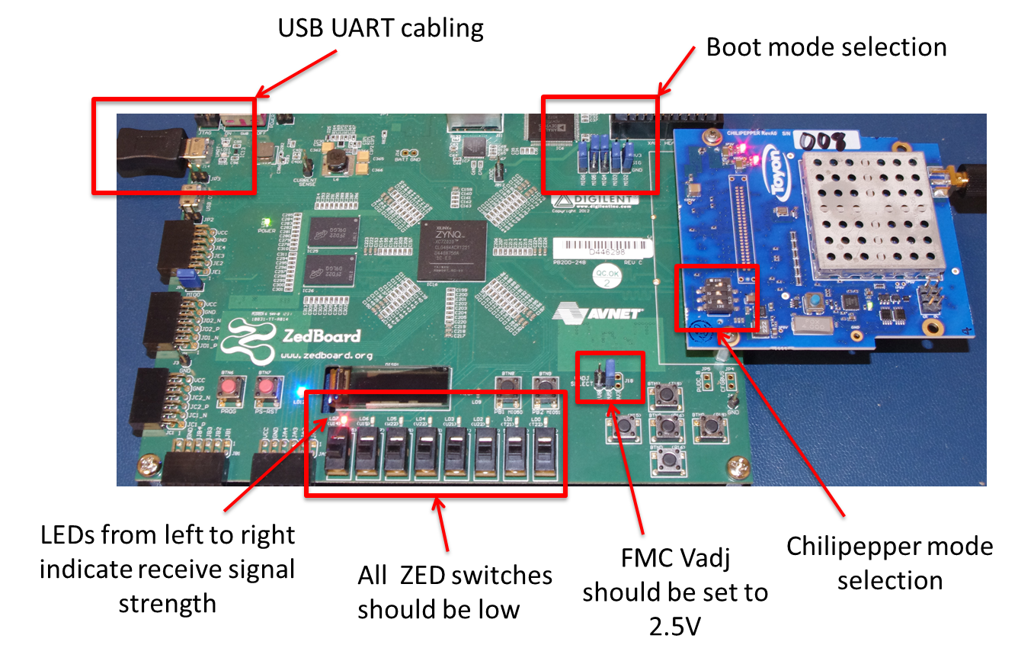

Figure - Illustration of connections and jumper/DIP/switch selection.

# Running the Demo

Prior to powering on the boards go ahead and open two terminal windows with 115200 baud. Upon power up you should see the following welcome screen on your two terminals (we are using TeraTerm but any terminal emulator should work fine).

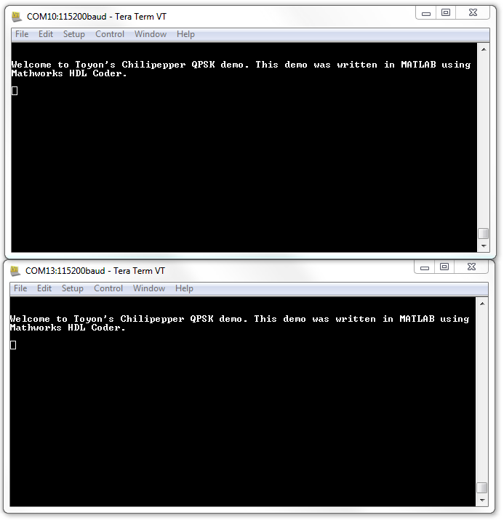

Figure - Welcome text at power on.

You should now be able to type characters in one window and have them show up in the other window.

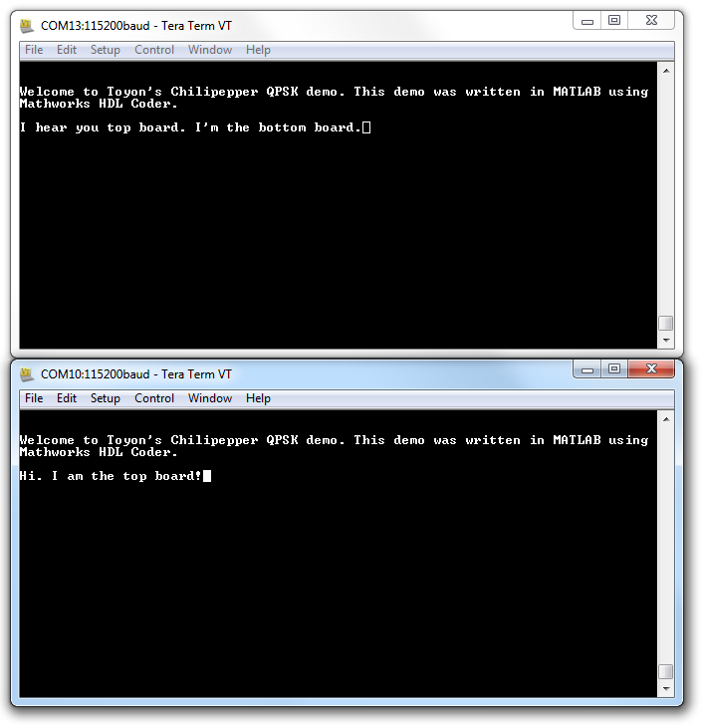

Figure - Typing text in one terminal should show up in the other terminal.